**COMMUNITY SERVICE, CLUBS AND SOCIETIES**

I served as a missionary for the Church of Jesus Christ of Latter Day Saints. I was called to the Guyana Georgetown Mission (formerly known as the Trinidad Port of Spain Mission). Each day I was required to talk to strangers, make intricate plans and schedules, construct and report statistics throughout the week, study extensively about the gospel, and serve others. I was unpaid, obedient to the missionary rules, and went out everyday whether it was rain or shine while serving in Guyana and Trinidad. I was placed in foreign and uncomfortable situations every day and made calm collected decisions under pressure.

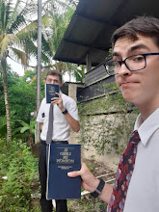

Extra-Curricular:

Participated in JV Tennis Spring 2018-2020

Varsity Cross Country Fall 2018

Marching Band Fall 2018-2022

Winter Percussion 2018-2022

Jazz Band Winter/Spring 2019, 2022

Made All District Band 2021

Solo and Ensemble Judging 2022 Member of Cyber Security Society 2024-2025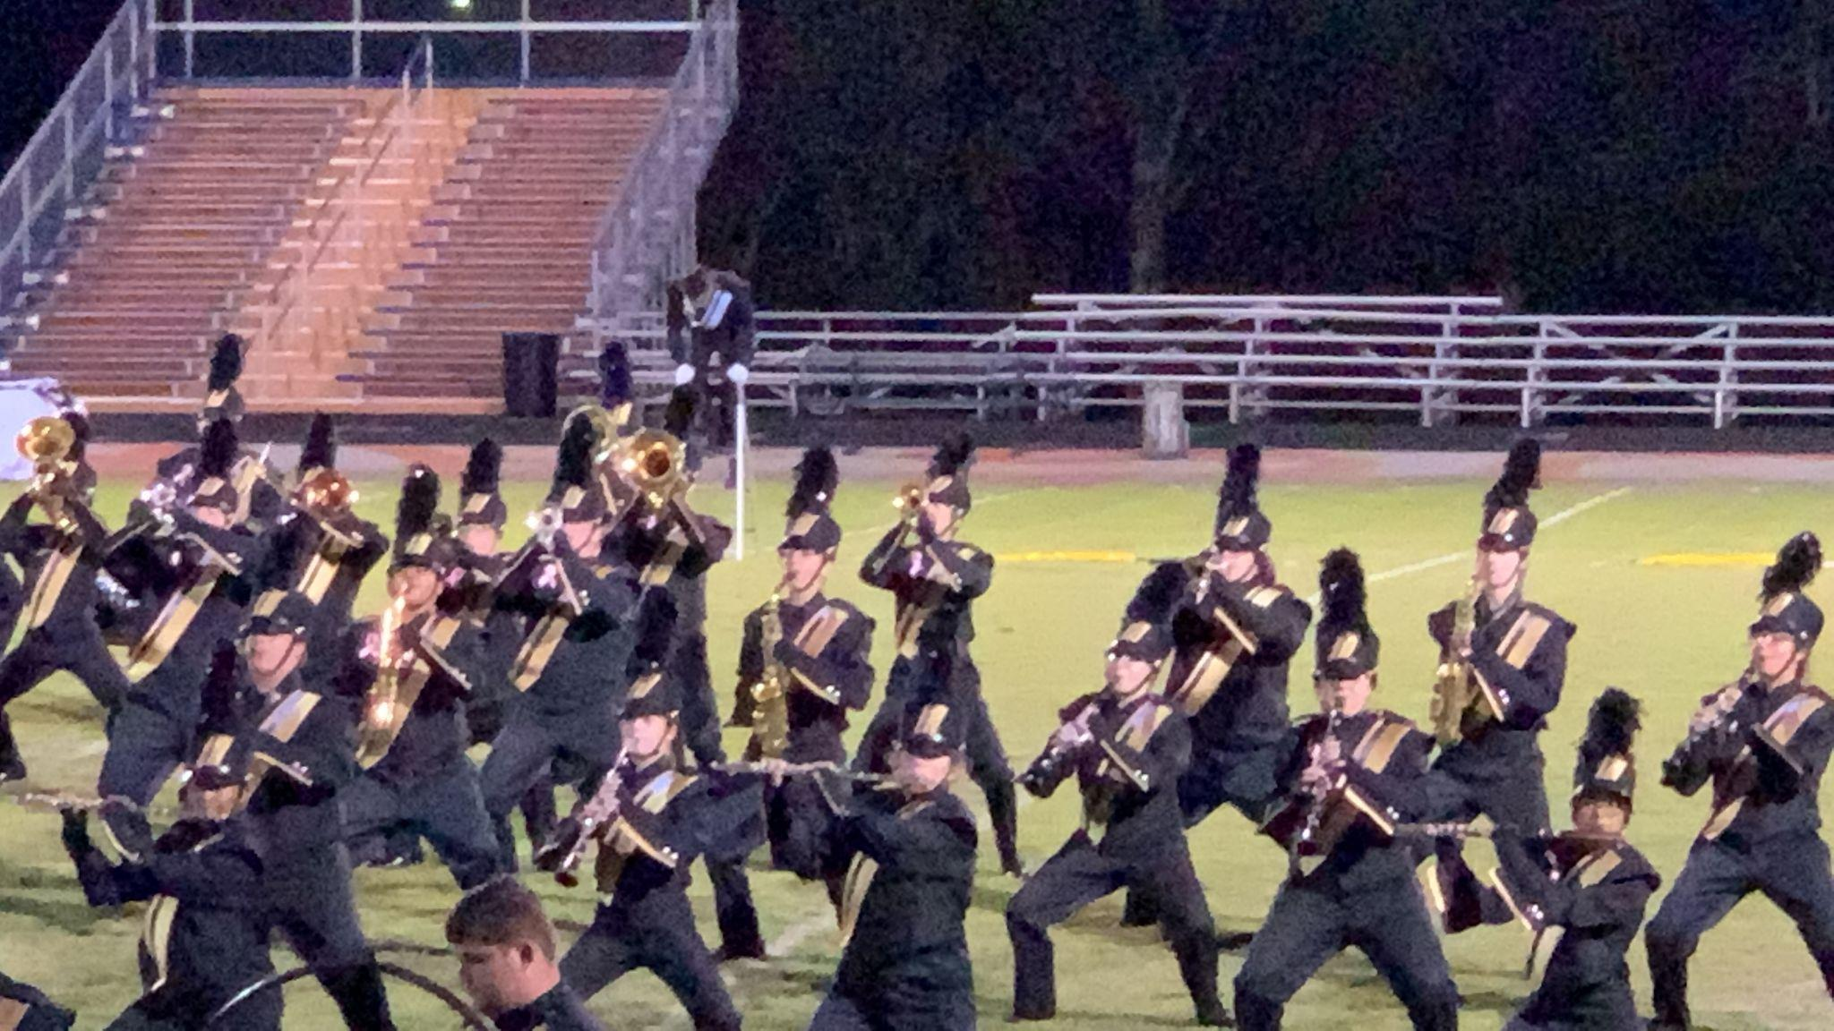

**WORK EXPERIENCE and SOFT SKILLS**

Jimmy John’s December 2019-May 2022

1024 N Dixie Hwy **Position:** Assistant Manager

Elizabethtown KY 42701

(502) 664-4742 Scott (Owner)

As an Assistant Manager at Jimmy John's, I played a pivotal role in ensuring the seamless operation of a consistently fast-paced and high-volume environment. Beyond the core task of crafting perfect sandwiches, I was directly instrumental in **managing all facets of daily operations**. This encompassed everything from meticulous **inventory control**, ensuring optimal stock levels and minimizing waste, to accurate **cash handling and reconciliation**, maintaining financial integrity. A significant part of my role involved **supervising and motivating the team**, fostering a collaborative and efficient workspace. I was responsible for **training new hires**, ensuring they quickly grasped our "freaky fast" service model and adhered to our rigorous **food safety and quality standards**.

Moreover, I actively **engaged with customers**, addressing any concerns and guaranteeing every individual received the exceptional service Jimmy John's is known for, directly contributing to customer loyalty and repeat business. I also took ownership of **maintaining store cleanliness and organization**, creating a welcoming atmosphere for both staff and patrons. Essentially, I served as a critical **on-site leader**, making rapid decisions to navigate challenges, optimize workflows, and uphold brand standards. I was the backbone of the store's smooth functioning, directly contributing to its efficiency, profitability, and the cultivation of a positive, high-performing team culture.

Hope to add more here soon !!!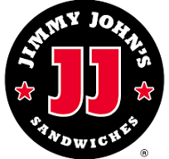

**Exceptional Time Management:** I consistently meet deadlines and maintain a flawless record of punctuality for all commitments, adhering to the principle that "to be early is to be on time." This proactive approach ensures efficient task completion and dependable attendance.

**Decisive Leadership:** My experience in various employment and mission leadership roles has cultivated a strong ability to foster inclusive environments and strategically delegate responsibilities, maximizing team engagement and productivity.

**Unwavering Integrity:** I am deeply committed to upholding my commitments, consistently following through on promises and tasks with steadfast reliability and honesty.

**Articulate Communication:** I confidently articulate ideas and opinions, readily seek clarification or assistance when needed, and consistently engage with colleagues and peers through clear, empathetic, and constructive dialogue.

**Confident Public Speaking:** I possess a strong aptitude for public speaking, capably delivering presentations and addressing diverse audiences, even with minimal preparation.

**ABOUT ME and EDUCATION {INDEX PAGE}**

BYUI University **Majoring in *Computer Science***

Total of **34 credits completed** and **15 credits in progress**

**Coding languages known**

Python

C#

Java Script

HTML

CSS

**Certifications**

CompTIA Security+ (Cyber Security)

AutoDesk Inventor Certified (3D modeling)

Bio

As a 21-year-old Computer Science student specializing in a Cybersecurity minor, Rylan Hoogland brings a unique perspective shaped by extensive relocation across the United States. With a background living in states such as Utah, Illinois, Hawaii, South Carolina, Kentucky, and Virginia, Rylan is developing a robust skill set aimed at contributing to national security.

He is an aspiring professional in the field of cybersecurity and computer science. Currently pursuing a Bachelor's degree in Computer Science with a minor in Cybersecurity, Rylan is actively preparing for a career with federal intelligence and law enforcement agencies, including the FBI and CIA. This ambition is fueled by a diverse upbringing that provided exposure to various regions of the United States.

